Problem 1: Arrange the parameters of RK4 in a Butcher Tableu

(1)

(2)

(3)

(4)

(5)

(6)

The Butcher Tableu representation of this method is:

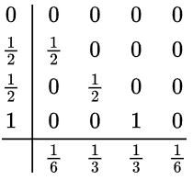

Problem 2: For the three RK methods shown below, given the Butcher Tableau representation, give the equations which define those methods.

Ralston Method

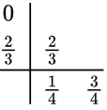

Heun Third-Order Method

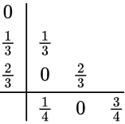

Runge-Kutta 3/8 Rule

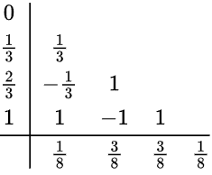

The equations for the Ralston Method are:

(1)

(2)

(3)

(4)

The equations for the Heun Third-Order Method are:

(5)

(6)

(7)

(8)

(9)

The equations for the Runga-Kutta 3/8 Rule are:

(10)

(11)

(12)

(13)

(14)

(15)

Problem 3: Implement the three methods discussed in Problem 2 in MatLab.

Code can be found in the GitHub page